[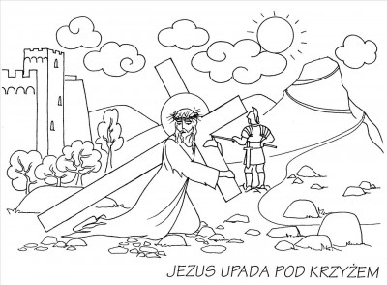](https://www.google.com/url?sa=i&url=http%3A%2F%2Fe-kolorowanka.pl%2Fgallery%2Fdroga-krzyzowa-kolorowanki&psig=AOvVaw2ydGRVjxRGMew-7aXTtTjG&ust=1585918251251000&source=images&cd=vfe&ved=0CAIQjRxqFwoTCPjCi4LkyegCFQAAAAAdAAAAABAE)