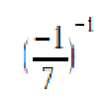 | R |  | 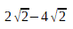 | T
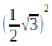 | P |  | 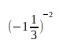 | S
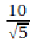 | M |  | 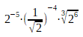 | Z
(2³)⁻¹ | A |  | 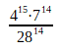 | E
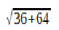 | Ć |  |  | W
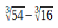 | S |  | 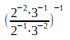 | O
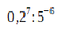 | Z |  | 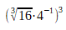 | E
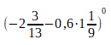 | I |  | 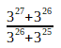 | Ę

 | Y |  | 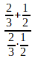 | Ć
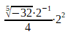 | D |  | 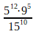 | Ś
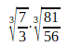 | I

