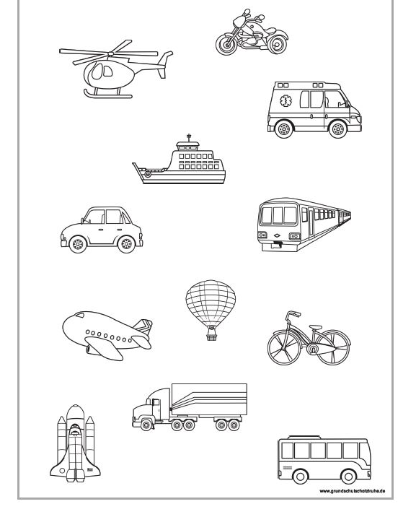
Pokoloruj:
car – yellow plane – blue bus – red train – black
bike – green rocket - brown

