Why is it worth coming to Nieledew!!

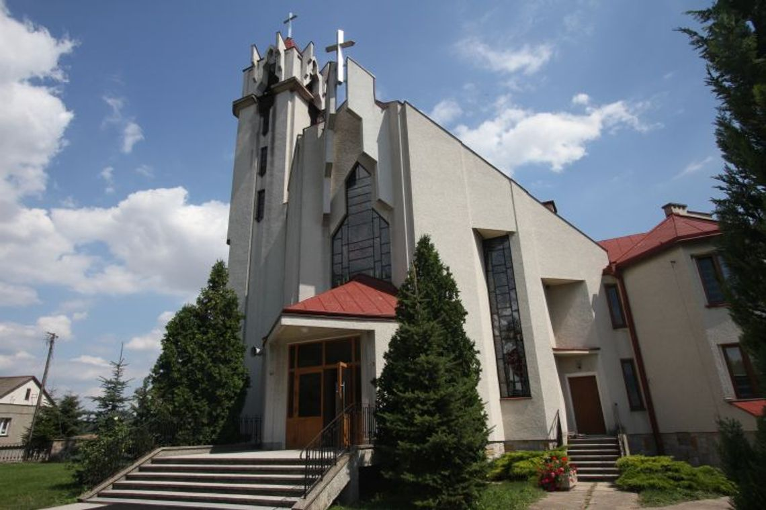

Nieledew has a nice church because it was renovated not so long ago.

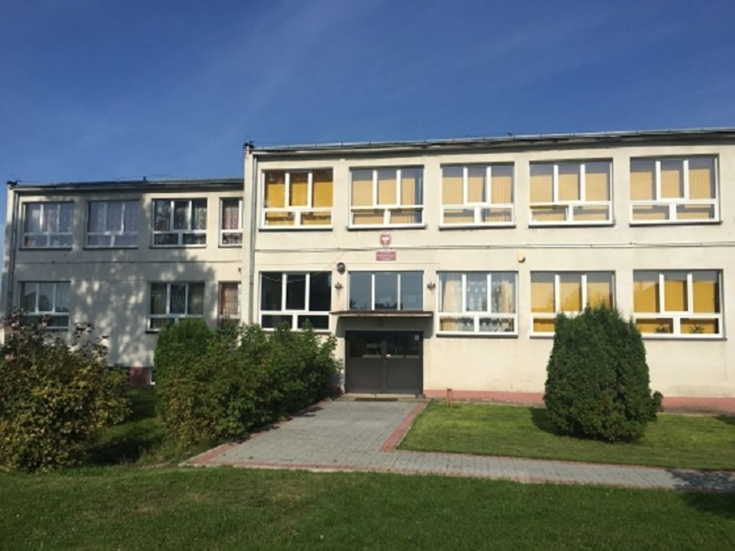

This is my school, it was renovated just like the church. The inside wasn't very beautiful, but now it's nice.

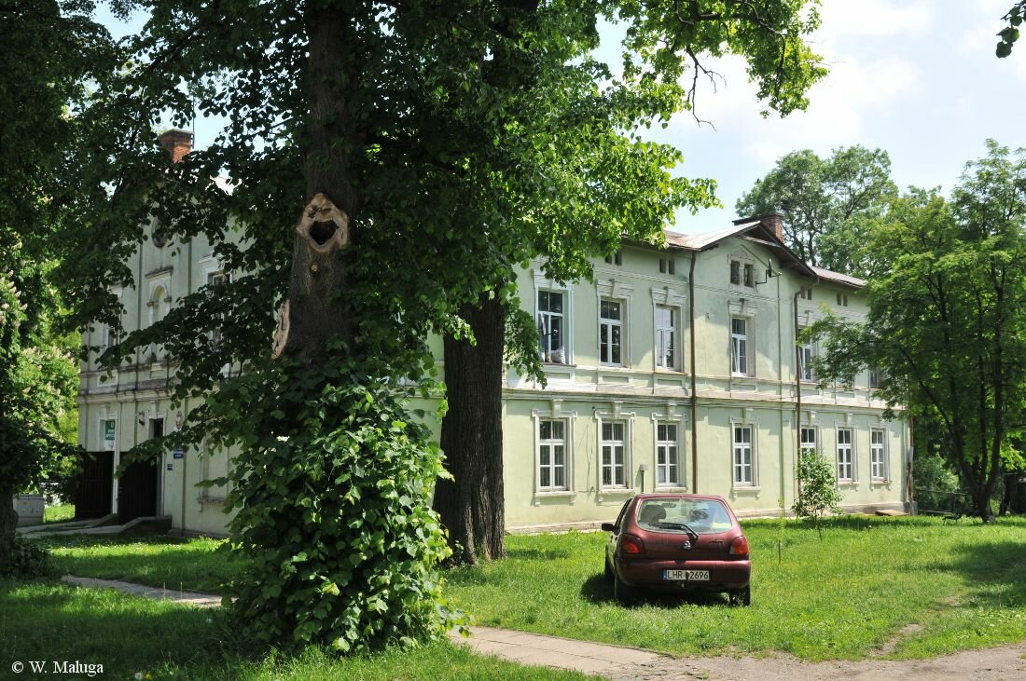

this is a health center that people have been going to for over a dozen years.