NIELEDEW

I’m from here ☺

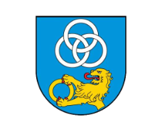 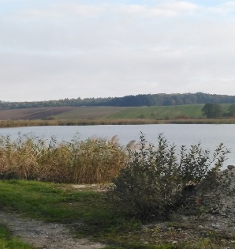 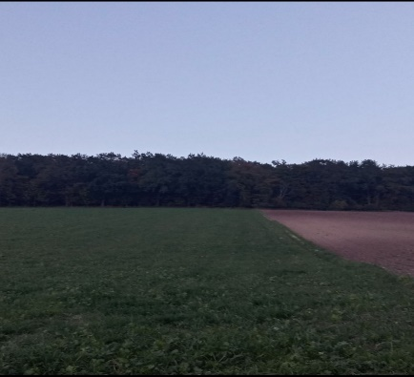

Water reservoirs, richly stocked with fish, attract much attention. Nieledew is located in the eastern part of Poland.

The reservoirs are eagerly inhabited by birds, and various species Nieledew is a perfect place for bicycle trips, walks in the forest, mushroom picking,

of ducks and swans. rest in silence, meetings accompanied by the sounds of frogs or fishing in a pond.

In Nieledew there are many green areas. meadows, mainly deciduous forests,

where many animals live .

Nearby the park there is a natural monument called Platon the Clone.

In the park you can relax and sit on a bench with friend.

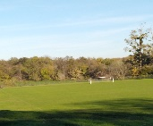

There is also a large football stadium   
in our town.

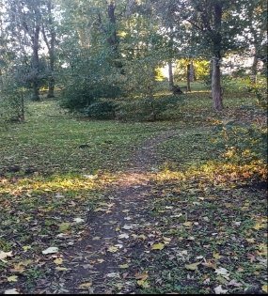

Various sports competitions take place there:

matches,

commemorative runs

and family picnics .