Nieledew

The village of Nieledew is located on the eastern edge of the Trzeszczany commune by the Białka River. It is a border zone.
Archaeological researches show that the cultural landscape
of Nieledew was shaped in the Neolithic and Bronze Age, later by the Przeworsk culture, then the Wielborz culture, to be dominated by the Slavic culture in the early Middle Ages.

HISTORY of NIELEDEW

This village was founded in 1444r. At that time, it was recorded in documents as NYELADWA. The cencus conducted in 1827r. recorded the village in the Hrubieszów district and the Trzeszczny parish. At that time, it had 55 houses and 301 inhabitants. Soon, the village was divided into two parts. The village had a water mill, a wooded parish church and a primary shool. Euchasty Świeżewski founded a park in Nieledwa, and in 1898, he built a sugar factory. Two administrative buildings and apartaments for employees were built next to it. In 1906, two more buildings were built in the sugar factory complex. After Word War II, the Hrubieszów Wiery was established in the buildings of the former sugar factory.

In Nieledew there is also the parish church of Our Lady of Częstochowa built in 1983-1987. The construction menager was Czesław Pieniążek from Chelm, and its parish priest was the builder Aleksander Miszczak.

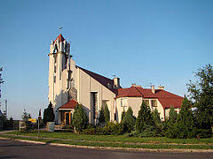

Historic and interesting places in Nieledew worth visiting

1. Remains of the Łaszcz- Nieledew manor house

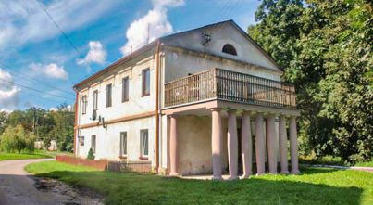
2. Sugar factory/ wine factory complex
3. Orthodox cemetery, formely Greek Catholic
4. Historic trees - remains of a landscape park
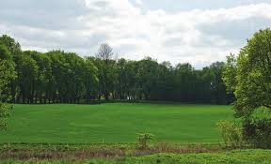
5. Community park with a pond
6. Antique sacral figurines
7. Remains of the manor house
8. Roadside brick figures (one figure of John the Baptist, the other on a mound surrounded by linden trees, on a quadrangular pedastal.
In the middle there is a cast iron Crucifix from the mid- 19th century.)
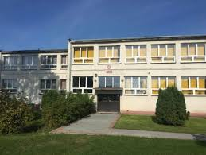
9. Stefan Żeromski Primary School

10. Community Centre and sports field in Nieledew

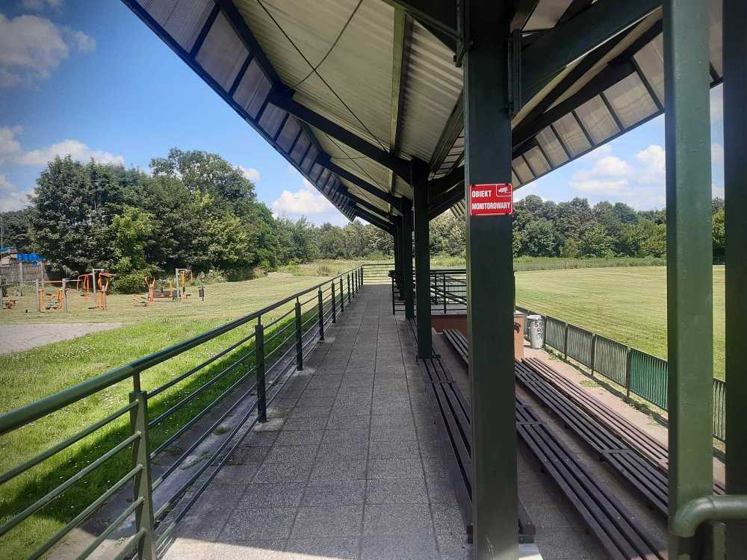

Typical occupations of the population

Agriculture dominates. The rest is employed in industry, trade education and administraton.

Nature

In the area of Nieledew there are many green areas of meadows, forests - mainly deciduous, in which many animas live, including roe deer, pheasants, hares and many others. In the town there are extensive water reservoirs richly stocked. The most colorful domestic bird - bee - easters, protected species, have their nests by the ponds.

