Looking for a nice and beautiful place ? We have that in Nieledew !

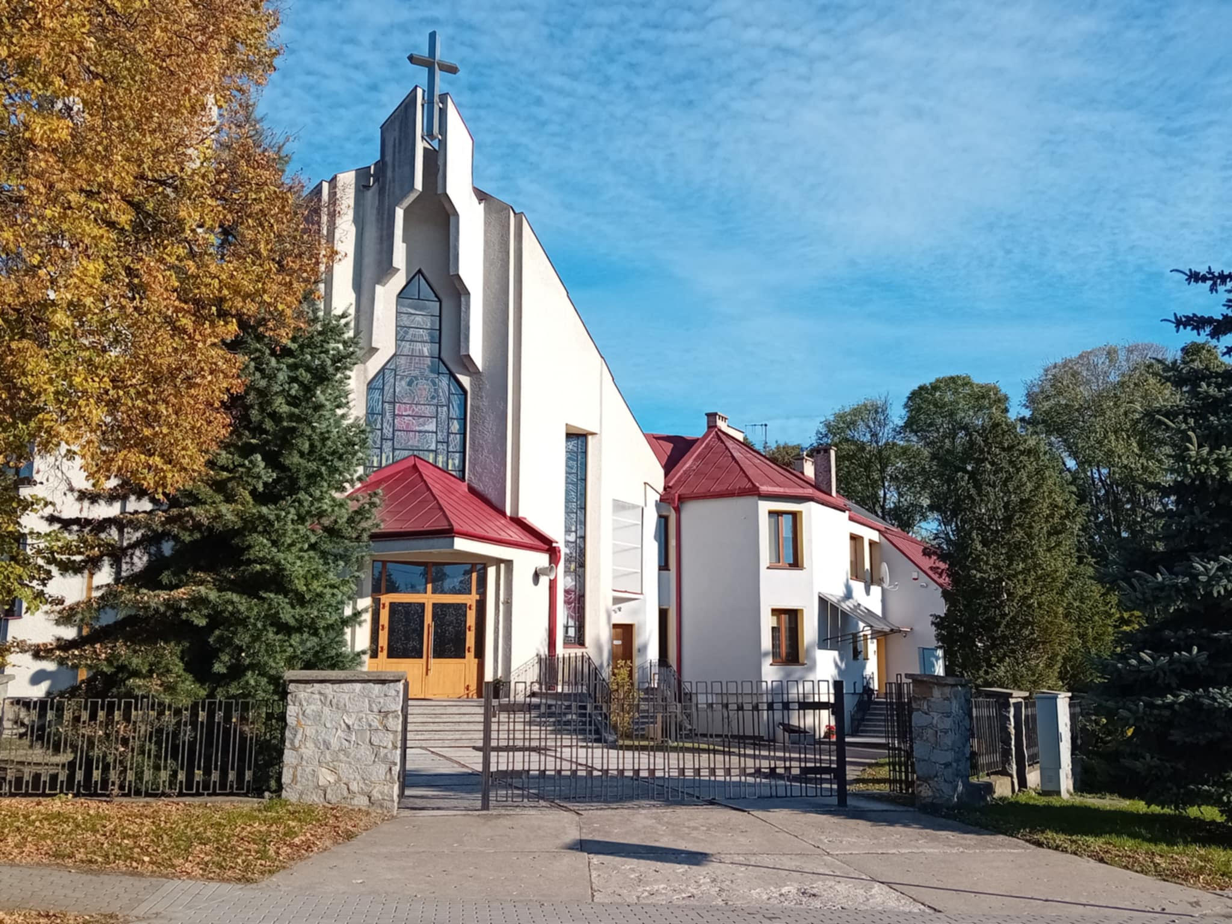
This is Matki Bożej Częstowskiej Catholic Church. Its design is very monumental. The church was built in 1985 and is standing there to this day.

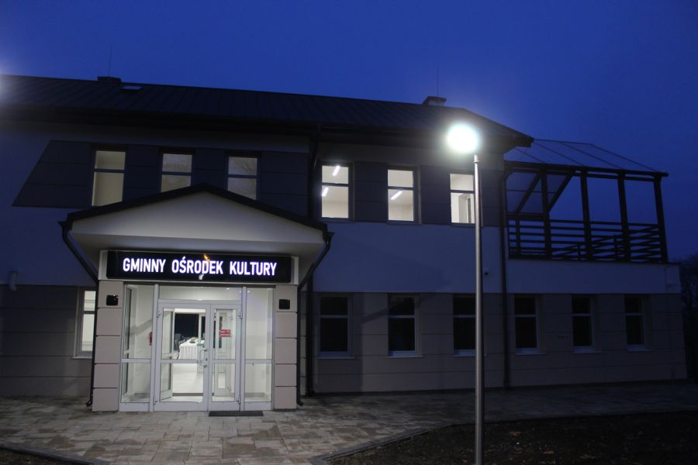
This is the center of culture in our village. You will find billiards
that you can play there. Also, if you like reading you can go to the library to read the best books of all time. If you like sport or want to keep fit you should visit the gym and work out. What is more, people can enjoy drama plays in this building.

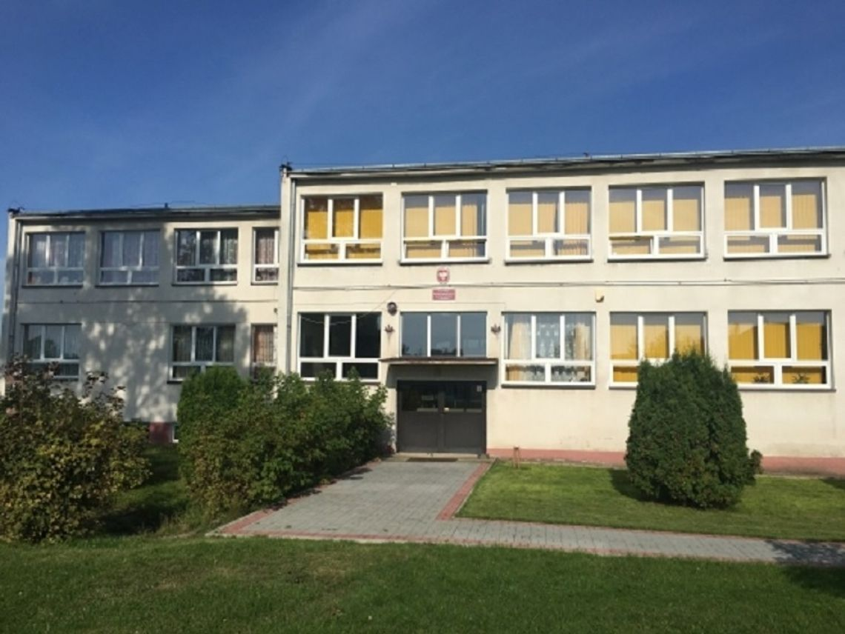
This is our school named after Stefan Żeromski. It was established in 1870. Originally, it was a Russian school. The building was modernised in 1965. Students learn maths, their mother tongue and other subjects here.

I recommend you to visit this charming place. Can’t wait to see you !

