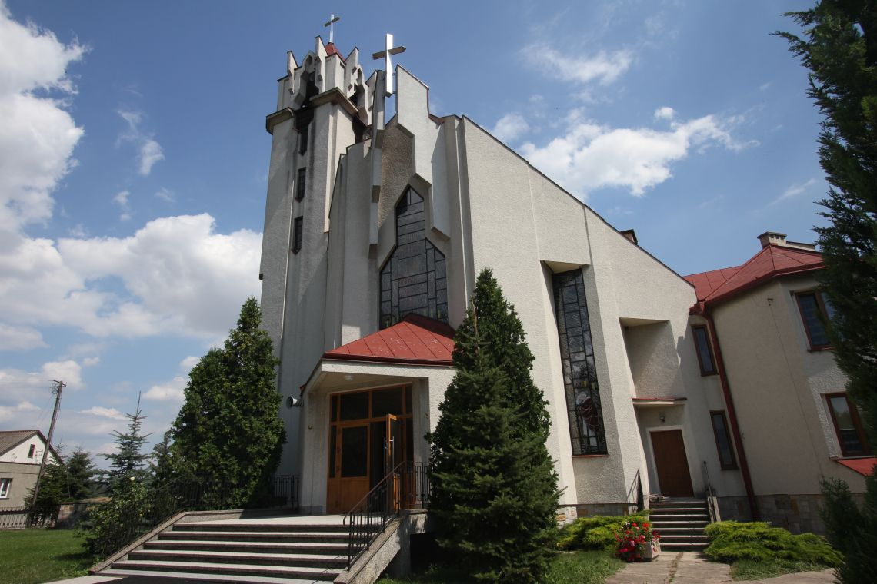

The Nieledew church has been serving for many years.

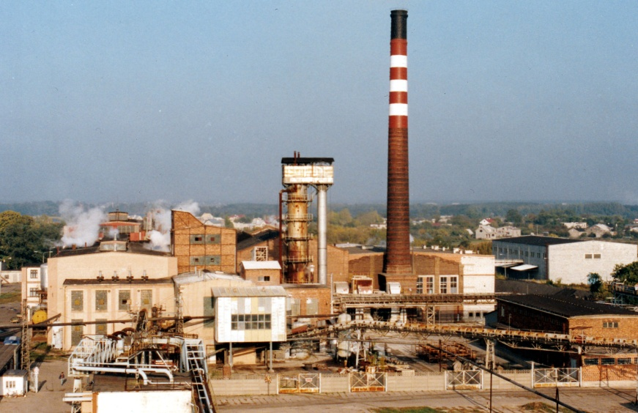

The plant called Real in Nieledew deals with, among other things, the production of juices, it also once made wine.

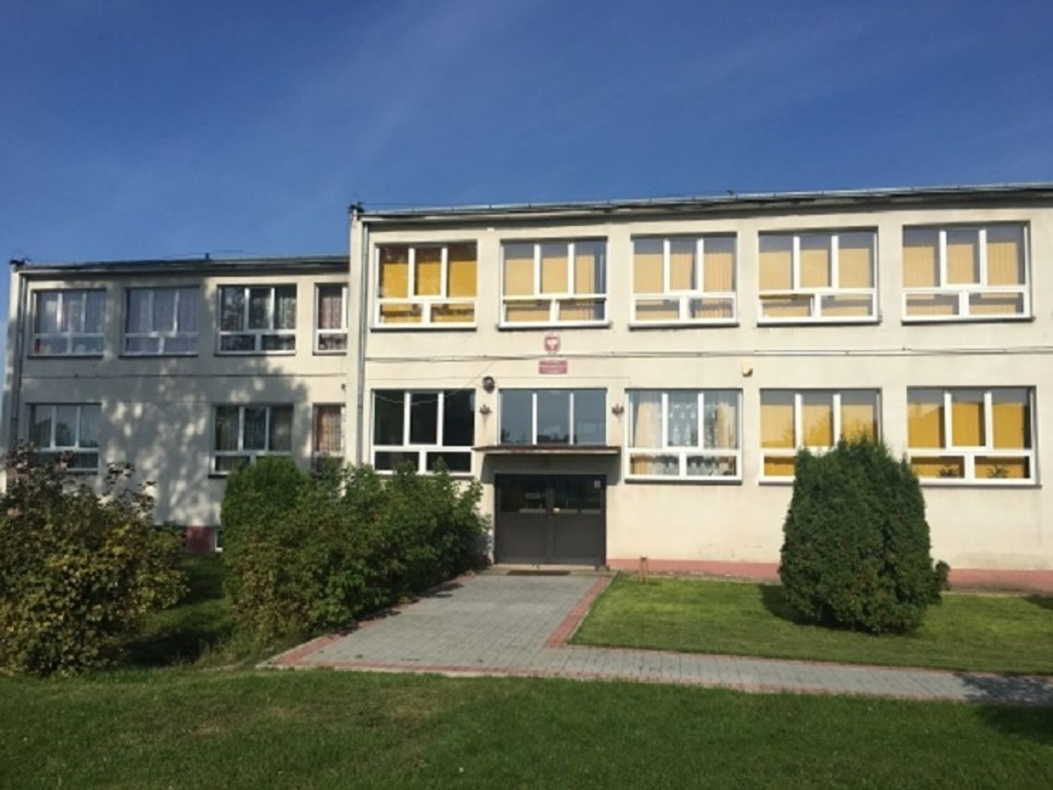

The school used to look worse, but the principal made a lot of renovations and it looks like new.

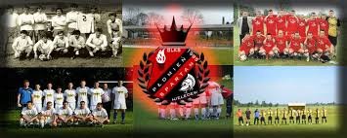

The football club was almost gone for several dozen years, but it returned and is still enjoyed by a large number of players.

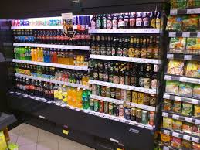

There is a grocery store where you can almost buy many everyday things.

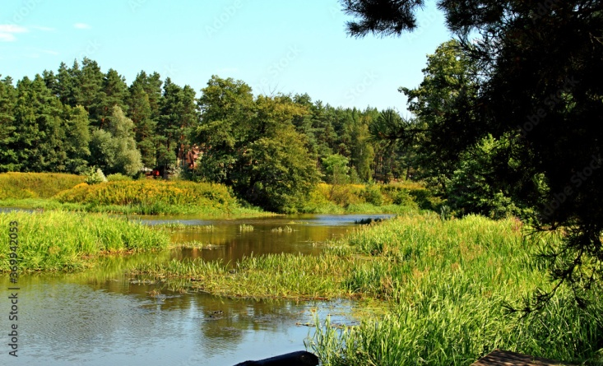

There are many reasons to live there, among others, it is a quiet village.