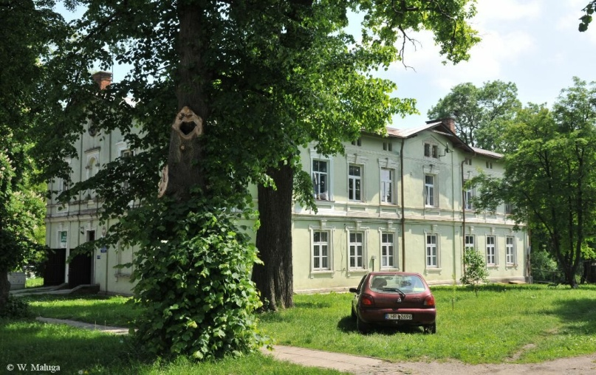

*Anna Hawryluk*

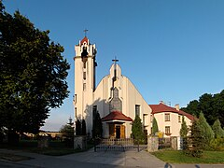

*Nieledew*

*interesting places in the area*

There are many interesting places nearby, including a beautiful park with a pond, historic buildings, a community center, but also buildings needed in everyday life such as a school,church and shops.