**MY DIARY**

18th November

I have no idea who invented November! Well, it seems that this person was not very clever. I still what time of the year it is - theoretically fall, but I’m not really sure… One day the sun is shining and it’s quite warm and then the next day it’s snowing and raining.

Can someone finally sort it out? Today was one of those boring, rainy days, during which I was sitting at home, on the couch, watching TV and eating dried apricots.

How boring was that.

I usually like Saturdays, but in November you can’t do a lot of things during the weekends. But December is a complete opposite! Then you can play outside when it’s snowing. Make a snowman - who would like to do a snowman from a November mud!? Believe me, it’s not fun at all. I tried and finished looking like that:



1st December

First December is the day of my name day. When I opened my eyes (my parents let me sleep longer today) I saw… my dream new wardrobe. It’s pretty, white with a big mirror. Exactly what I wanted. I got up and looked inside quickly. I couldn’t believe my eyes! T-shirts, blouses, trousers, shorts, dresses…I jumped with joy! Although there weren’t any designer clothes I was still happy. I'got a very lovely gift.

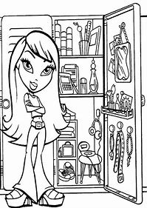

24th December

Christmas Eve is my favorite day of the year (right after my birthday). The things that I like most about Christmas Eve are, of course, presents. I try not to sleep at all during that night so I am able to see when my parents put the gifts under the Christmas Tree. Then I can unpack them immediately. However, I have never succeeded. It’s hard to sit under the Christmas Tree when the needles are falling on my head all night. Except that my parents are too lazy to put gifts at night. They usually do it in the morning when I’m so tired that I fall asleep. So, this year I will sleep in my bed because I’m comfortable with it. The gifts won’t escape anyway.



Friday, 13th January

I hate Friday the thirteenth! Not that I’m superstitious or something, but on that day I always have a bad luck. Do you want a proof? Ok! Let’s for example talk about today. I was half an hour late for school, because my alarm clock broke down. In the third lesson I realised that I forgot about my English test. It definitely didn’t go well. Then I went to the canteen on the lunch break and realised that I forgot to pay for my lunch today! Of course I didn’t have any money. I was veru hungry. I didn’t have breakfast because of the broken alarm clock. In my opinion, going to school on Friday the thirteenth should be banned!

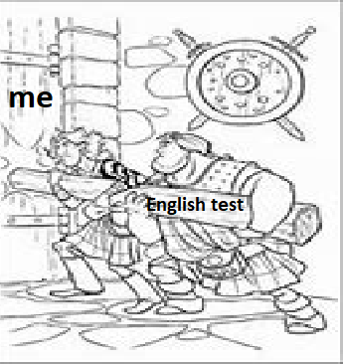

25th January

Hurray! We are in the mountains in Czorsztyn. We have already eaten a tasty dinner and we are going to go outside. Although I hate putting on ski clothes, I knew the fun was awaiting us. We have decided to make a snow battle! Together with our friends, we have agreed that we would gather as much snow as possible and throw it at our parents. They will be as white as snowmen.

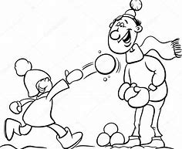

30th January

Skiing… usually it’s nothing special for me. Skiing all day outside at -10 degrees when it’s snowing all the time isn’t particularly my favorite activity. I don’t know why everybody loves skiing so much.

This year, hoverer, is different. The mountain we ski on, has got a couple of slopes, the weather is great - only 2 or 0 degrees… In the middle of the slope there is an amazing restaurant where we eat our lunch. I think I might start liking skiing after all.



4th February

Dog… human’s best friend. And my parents say firmly 'no'! Don’t they care about their children happiness? Not exactly. They think we should be more responsible, independent and above all to start helping more at home. It seems easy, but… my brother and I have already tried twice, but without any success. Today we are trying again. Now we are a year older so hopefully this time we will succeed. The idea of cute, small puppy is great! It motivated us to start working. We made a table with five challenges:

1) Putting things back on the place

2) Packing our backpacks

3) Emptying the dishwasher

4) Vacuuming

5) Preparing one meal per week

Off we go!



11th February

It’s been a week since I have started the 'dog project'. For now, it’s a success. Mum said: good job my dear, and gave us points on our table with challenges. It’s true that my brother hardly ever goes into his room because he says it’s the easiest way to keep it clean, but we’re still doing well. There are ten weeks left… I hope we can do it.

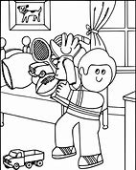

17th February

Unfortunately, the prophecy proved that if anything that can go wrong will go wrong. We haven’t gone through the trial. We have failed completely. It turned out that it was too difficult to combine the student’s (the enormity of housework overwhelmed us) and home duties. Thus the dreams about having a dog will have to wait until we learn to manage our time better. Because the time won't stretch like rubber. For now, the pictures of the dog on the board in my room have to be enough. The dog on the pictures is nice and I don’t have to take care of it.



23rd March

Today’s my parents wedding anniversary. Together with my brother we decided to surprise them and prepare food for the whole day. For breakfast we prepared sandwiches and coffee. It was very east to made and our parents liked it. We made a creme vegetable soup and duck with apples for lunch. That was more difficult to prepare than sandwiches but everything went well. Finally, we made corn pancakes for dinner.

I’m so tires… It’s good that my parent will prepare tomorrow’s meals again. The day spent in the kitchen wasn’t particularly fun. Fortunately it was only one day during the year!



21st April

Easter… it’s not only a tasty breakfast with the family. My grandma is a real masterchef in the kitchen - her żurek is the best I have ever eaten. I really like the family atmosphere and above all - the eggs… battle! We play it every year and my dad always wins. How do we play it? My grandma cooks hard-boiled eggs for each family member and then we knock them with other eggs. The person, whose egg doesn’t crack is the winner. This year my egg won!



10th June

Summer is an amazing time of the year. Sun is shining, it’s warm, you can have a long walks in the park, cycle, rollerblade…

But what about school in the summer? It’s a total mistake! Not only it’s almost 40 degrees outside, but also I have the impression that someone forgot to switch the heating off! It’s not that easy to sit and focus in the classroom when you’re about to choke from the heat! I can’t remember anything I heard about the gold rush in Alaska because of the class temperature. As a consolation, holidays are only a couple of day away. And then all the heat will not bother me at all. On the contrary, it will be desirable! I love spending time outside when it’s hot! We have a small pool in the garden and I can invite some of my friends to swim with me!

