Test 4A
Name _____________________________ Class _______
A Read and match. Przeczytaj i połącz:. Przeczytaj, napisz i połącz. P PP
I can buy a | 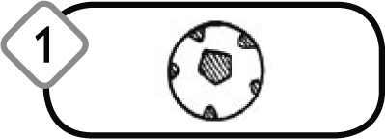 |  | a. at the newsagents.
I can buy a | 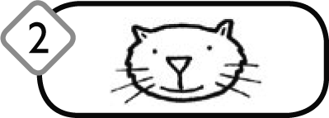 |  | b. at the pet shop.
I can buy a | 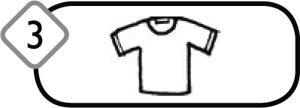 |  | c. at the clothes shop.
I can buy a | 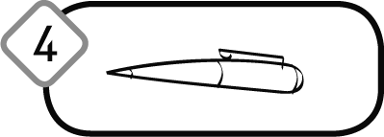 |  | d. at the sports shop.
B Read and match, then write the prices./Przeczytaj, połącz cenę z odpowiednim zdaniem i napisz odpowiednie ceny na obrazkach:
Przeczytaj i napisz
 |   1.£36  2.£1.50  3.£15  4.£3.75  5.£25 |  |  | a. The skateboard is fifteen pounds.
 |  |  |  | b. The pencils are one pound fifty pence.
 |  |  |  | c. The jacket is twenty-five pounds.
 |  |  |  | d. The shoes are thirty-six pounds.
 |  |  |  | e.The flowers are three pounds seventy-five pence.
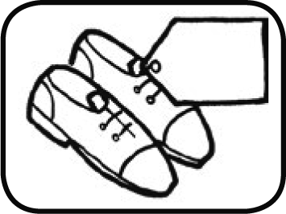 |  |  | 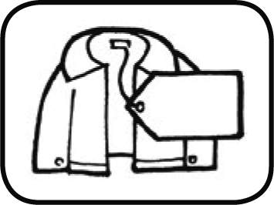 |  | 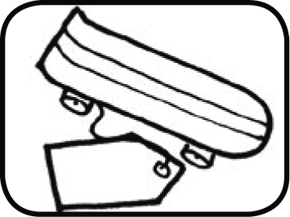 |  | 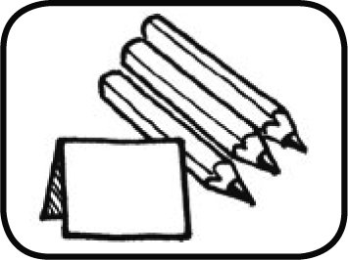

C Write./Rozpisz słownie: Napisz.
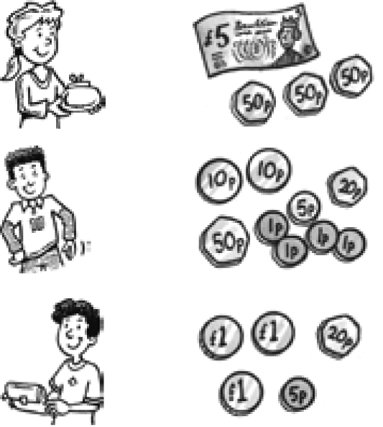 |  | She has ______ pounds and _________ pence.
( |  | He has___________________________pence.
 |  | He has______ pounds and __________ pence.

Objaśnienie do zad. C:
1. £ 6.50
2. £ 0.99
3. £ 3.25
GOOD LUCK! POWODZENIA!

15- 17- bdb
12,5-14,5- db
8,5-12-dst
6,5- 8- dop
0- 6- ndst

