Test 4A Name \_\_\_\_\_\_\_\_\_\_\_\_\_\_\_\_ Class \_\_\_\_\_\_\_ Date \_\_\_\_\_\_\_

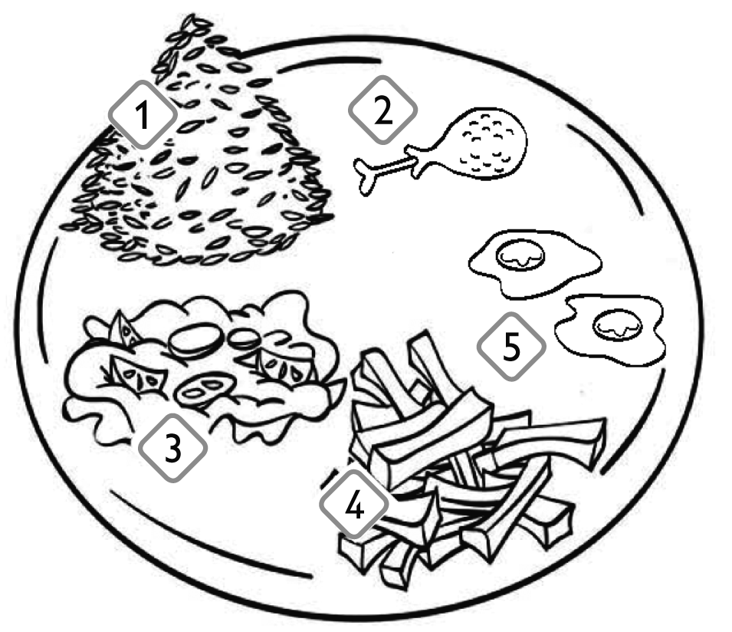A Look and write. Popatrz i napisz.

|  |  |  |
| --- | --- | --- |
| 1 | SSPKP2_13aCan I have some | ? |
| 2 | SSPKP2_13b | ? |
| 3 | SSPKP2_13b | ? |
| 4 | SSPKP2_13b | ? |
| 5 | SSPKP2_13b | ? |

|  |  |  |  |  |  |  |
| --- | --- | --- | --- | --- | --- | --- |
| B Look and write. Popatrz i napisz. | |  |  | like | don’t like |  |
| 6 | SSPKP2_13dI like |  | I | tick |  | SSPKP2_13g |
| 7 | SSPKP2_13eI don’t like |  |  | Cross | SSPKP2_13h |
| 8 | SSPKP2_13f |  | tick |  | SSPKP2_13i |
| 9 | SSPKP2_13f |  |  | Cross | SSPKP2_13j |
| 10 | SSPKP2_13f |  | tick |  | SSPKP2_13k |

C Look and write. Emma’s favourite food is …

Popatrz i napisz. Ulubione jedzenie Emmy to … Ułóż nazwy jedzenia z rozsypanych wyrazów:

|  |  |  |  |  |  |
| --- | --- | --- | --- | --- | --- |
| 11 | SSPKP2_13l | 12 | SSPKP2_13m | 13 | SSPKP2_13n |
| 14 | SSPKP2_13o | 15 | SSPKP2_13p |  |  |

D Read and number. Przeczytaj i ponumeruj- **(rice, chicken, bacon, eggs, salad, ice-cream)**

|  |  |  |  |  |  |  |
| --- | --- | --- | --- | --- | --- | --- |
| p34a | p34b | p34c | p34d | p34e | p34f |  |
| p34n | p34n | p34n | p34n | p34n | p34n |  |

E Write in order. Napisz w odpowiedniej kolejności.

|  |  |
| --- | --- |
| p34hLozenge 22 | p34g |
|  | |
| p34hLozenge 23 | p34i |
| . . | |
| Lozenge 24p34h | p34j |
| p34kLozenge 25 | |
| p34h |  |
| Lozenge 26p34l . | |
|  |  |
| p34h | |

F Write about you. Dokończ zdania, wpisz nazwy potraw:

|  |  |
| --- | --- |
| Lozenge 27 | p34mI like |
| Lozenge 28 | p34mI don’t like |
| Lozenge 29 | p34mI love |
| Lozenge 30 | p34mMy favourite food is |

|  |  |  |  |  |  |  |  |  |
| --- | --- | --- | --- | --- | --- | --- | --- | --- |
|  |  |  |  |  | My mark is |  | / | 30 |