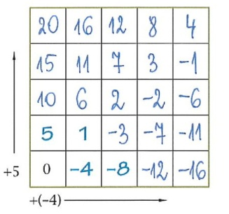

ćw. 6

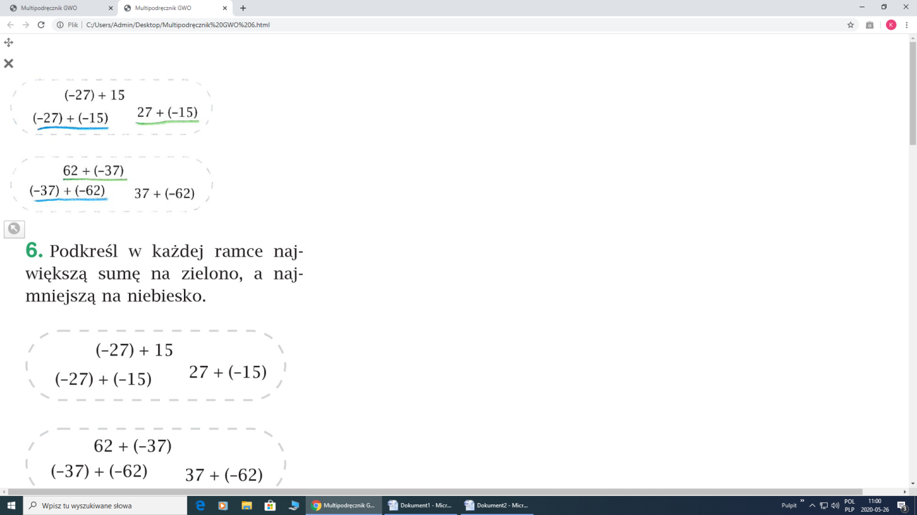

ćw. 7

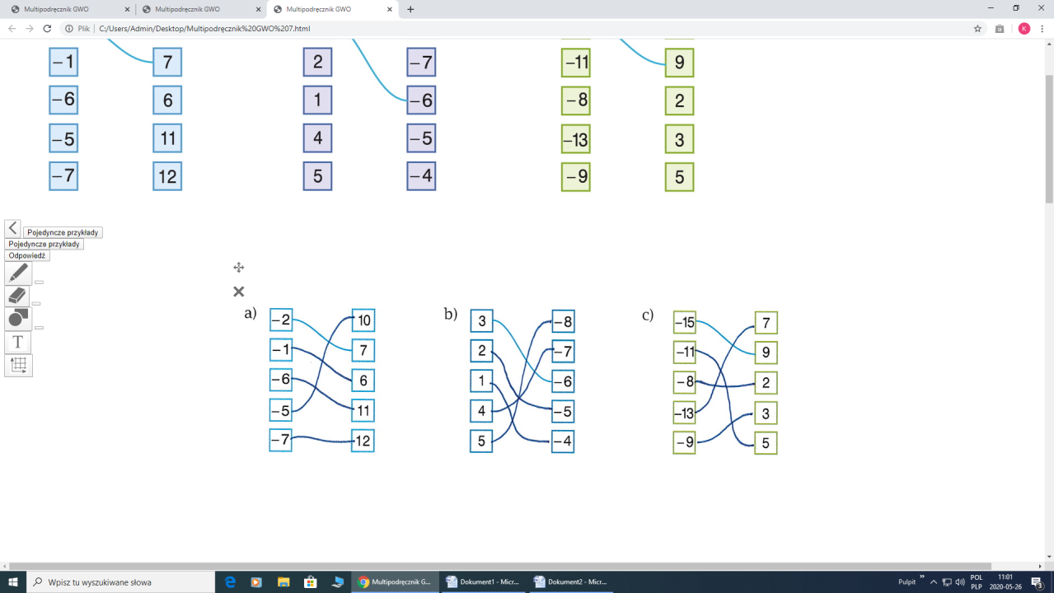

ćw. 8

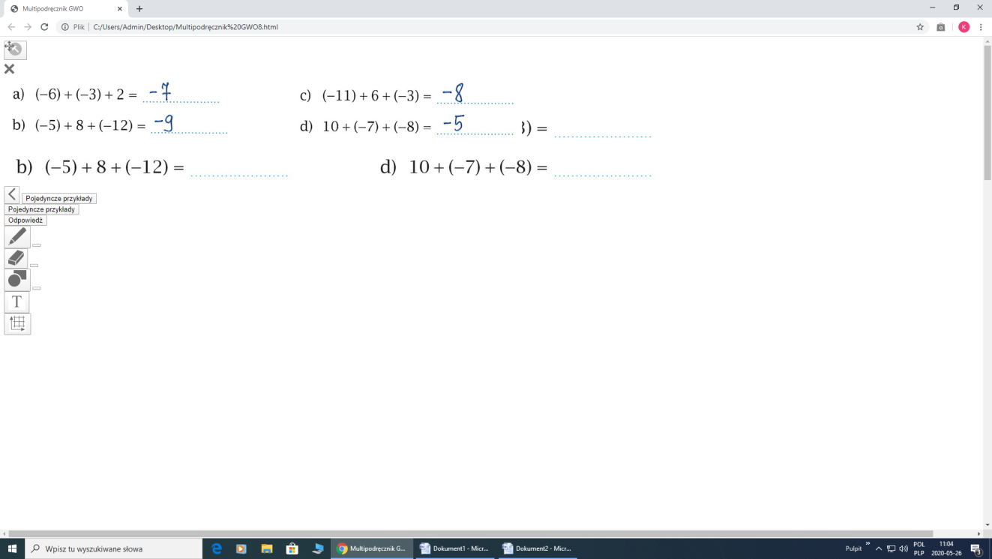

Zadania z podręcznika:

Zad. 1/213

1. (-5) + 7 = 2 b) ( -8) + ( - 7) = - 15 c) 6 + ( -12) = - 6

(-10) + 20 = 10 (-21) + (- 42) = - 63 7 + ( -10 ) = - 3

( -100) + 90 = - 10 ( -25) + (-11) = - 36 12 + ( -3) = 9

( - 40 ) + 1 = - 39 (-75) + (- 45) = - 120 15 + ( - 28) = - 13

Zad. 2/213

1. (-1) + 8 = 7, (-5) + 8 = 3, (- 4 ) + 8 = 4, (- 8) + 8 = 0, (-10) + 8 = - 2, (-15) + 8 = - 7
2. (-2) +( - 12) = - 14, (-10) + ( -12 ) = - 22, 5 +( -12 ) = - 7, ( -12 ) + ( -12 ) = - 24, 20 +( -12 ) = 8,

100 + ( -12 ) = 88

Zad. 3/ 213

1. ( - 5) + 12 + ( - 6 ) = 1 c) 20 + (- 9 ) + ( - 10 ) = 1 e) 27 + ( - 12 ) + ( - 15 ) = 0
2. ( - 8) + ( - 4 ) + 6 = - 6 d) ( - 7 ) + ( - 9 ) + 16 = 0 f) ( - 20 ) + 17 + ( -3 ) = - 6

Zad.4/213

1. ( - 5 ) + 12 + ( - 4) + - 3 = 0 b) ( - 8 ) + ( - 5 ) + 11 = ( -6 ) + 4

Zad.5/213 a) 2 b) -5 c) -1