[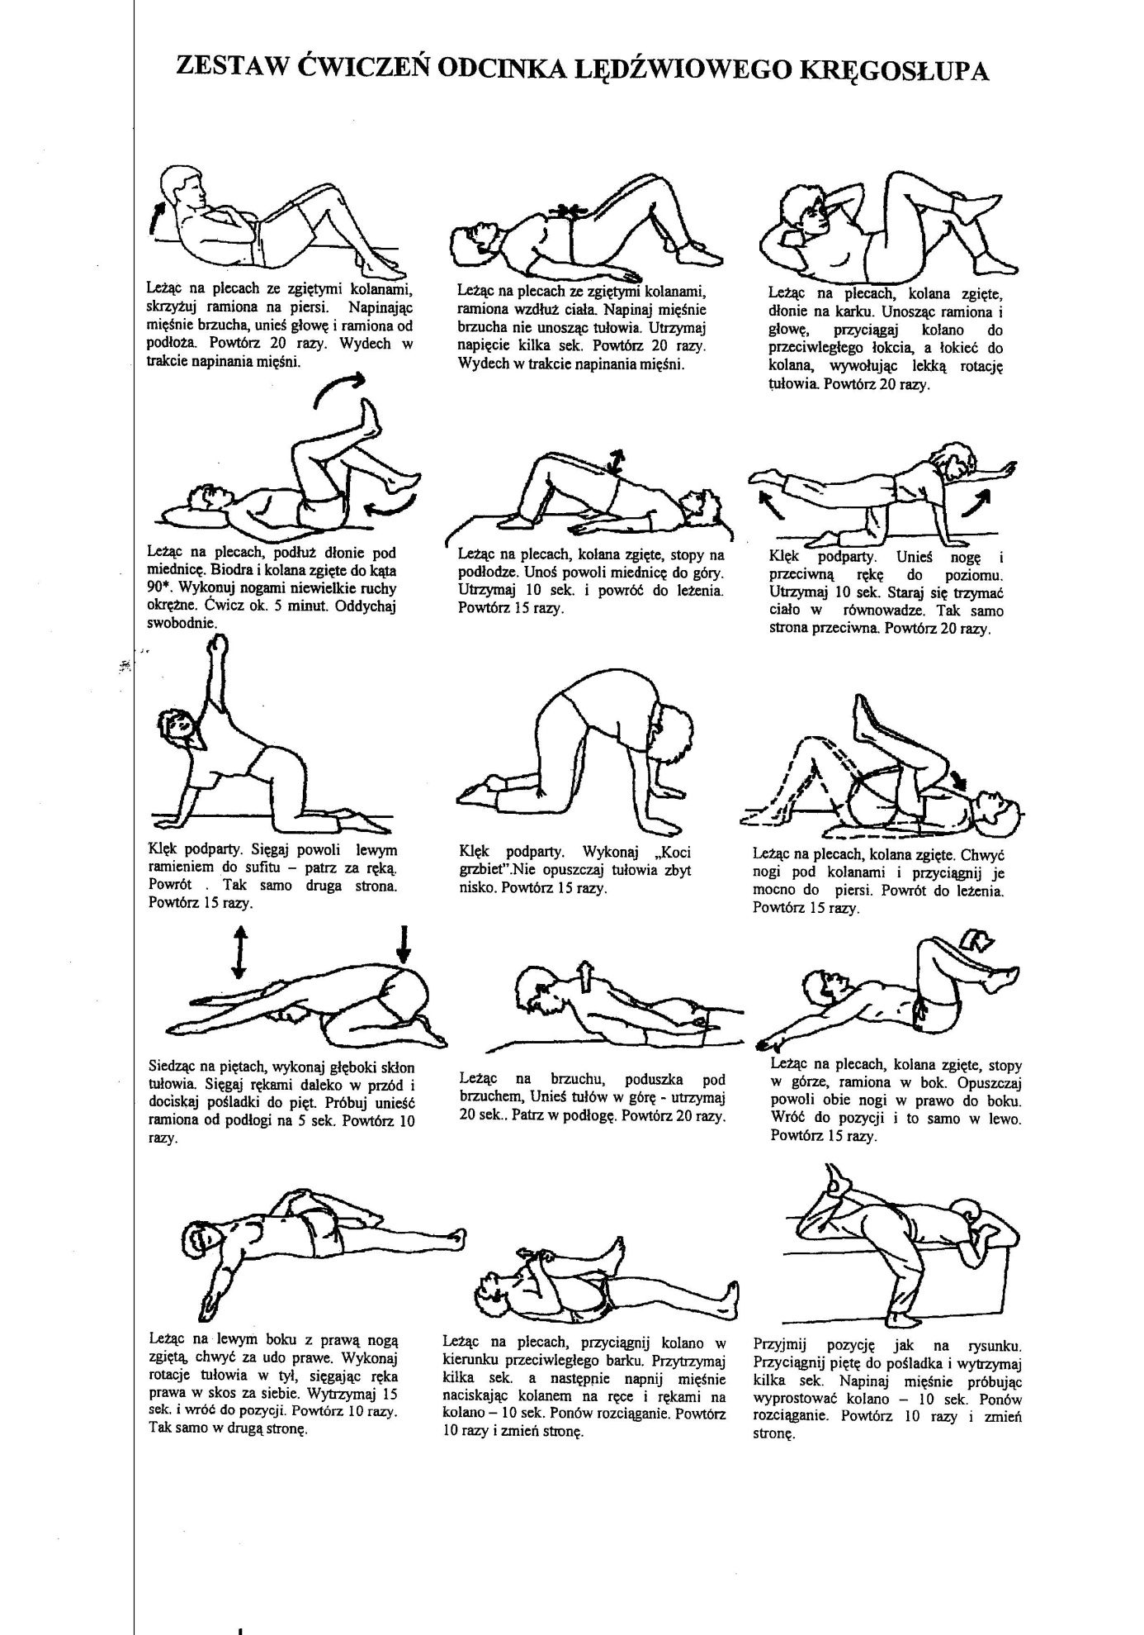](https://www.google.com/url?sa=i&url=https%3A%2F%2Fspmich.edupage.org%2Ftext%2F%3Ftext%3Dtext%2Ftext11%26subpage%3D14&psig=AOvVaw1S8Qkw45byOmlrd-ky3V5Q&ust=1590395610697000&source=images&cd=vfe&ved=0CAIQjRxqFwoTCIjvl76LzOkCFQAAAAAdAAAAABAT)