

My favourite Polish musician is

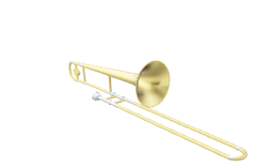
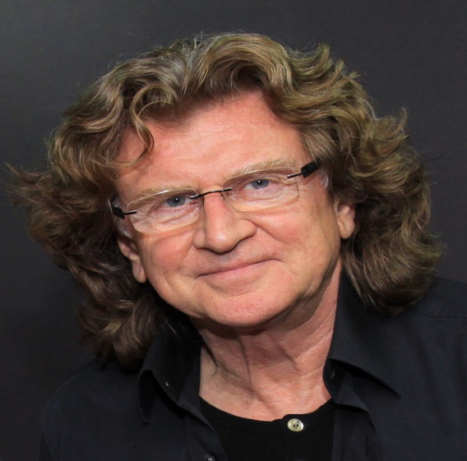
Zbigniew Stanisław Wodecki
(born May 6, 1950 in Krakow, died May 22, 2017 in Warsaw)
Polish singer, multi-instrumentalist, composer, arranger, actor and TV presenter.
He is my favourite musician for his music and songs. He began his musical career in the 1960s, playing the violin in the groups Czarne Perły and Anawa. In the 70s he made his debut as a singer. Since his debut, he has released solo studio albums: Zbigniew Wodecki (1976), Women's souls (1987), Zbigniew Wodecki '95 (1995), Beside myself (2002) and Platynowa (2010), as well as the album entitled 1976: A Space Odyssey (2015) with the band Mitch & Mitch and two Christmas albums - Gwiazdo Świeć, kolędo fly (2014) and ... Christmas carols (2018).
My favourite songs sung by him are: "I like to go back to where I was", "I want to see the world with you", "Start with Bach", "Isolde", "Tell me yes" ". He was also popular with his performances of the title songs from the animations by Maya the Bee and Rudolf the Red Nosed Reindeer.
Multiple prize winner at the National Festival of Polish Song in Opole. Two-time laureate of the Artistic Prize of the Polish Stage "Prometheus", two-time winner of the Fryderyk and the Golden Fryderyk. Decorated with the Medal for Merit of Culture, the Silver Medal for Merit to Culture - Gloria Artis, the Medal Honoris Gratia and posthumously with the Officer's Cross of the Order of Polonia Restituta.


