**He likes cheese** **Test**



|  |  |  |  |  |
| --- | --- | --- | --- | --- |
| Imię i nazwisko | ......................................................................... | |  | Klasa .................. |
| **RAZEM:** ............ | **/ 15** | 0 – 7 | 8–11 | 12–15 |
| **1 Listen and number.** | | | **AUDIO** |  |
| **12** |  |



Posłuchaj i ponumeruj.

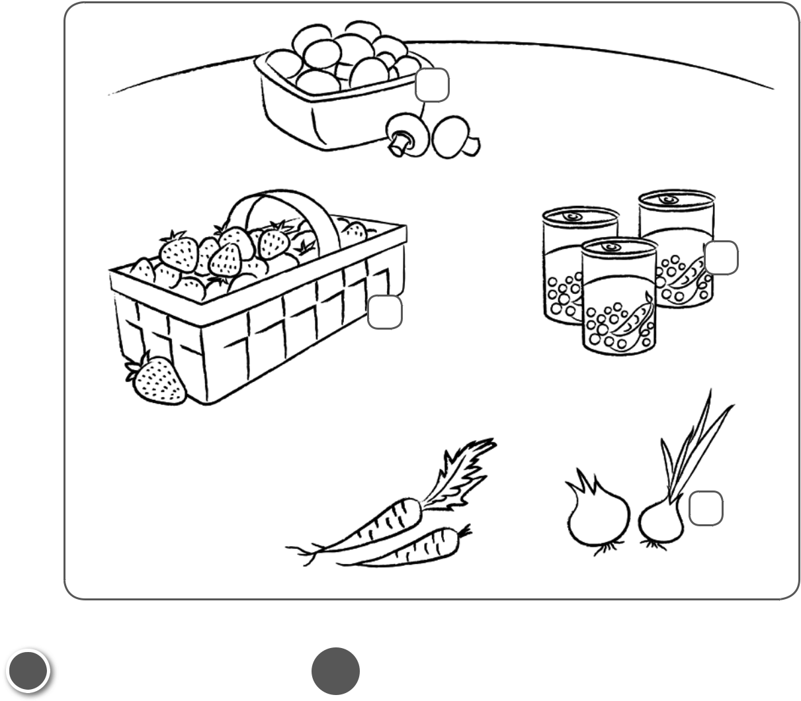

**UNIT**

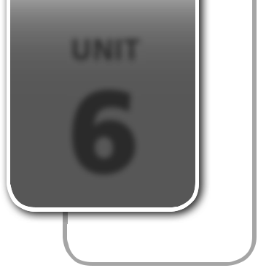

**6**

............ **/ 4**

1. **Listen and match.**

Posłuchaj i połącz.

1. She likes
2. She doesn’t like
3. He likes
4. He doesn’t like

|  |  |
| --- | --- |
| **AUDIO** | **/ 4** |
| **13**............ |

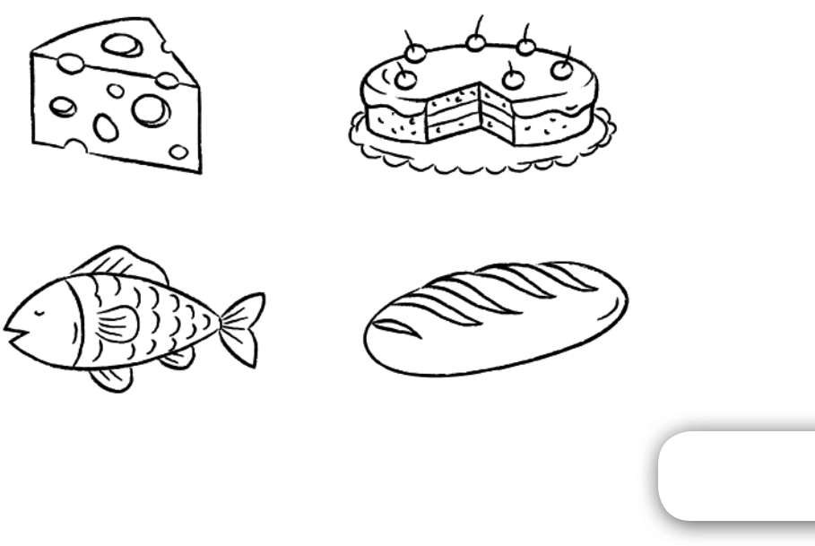

PHOTOCOPIABLE © Pearson Education Ltd. 2016 *New English Adventure 2* **21**

**3 Look, read and circle.** ............ **/ 5**

Popatrz, przeczytaj i zakreśl.

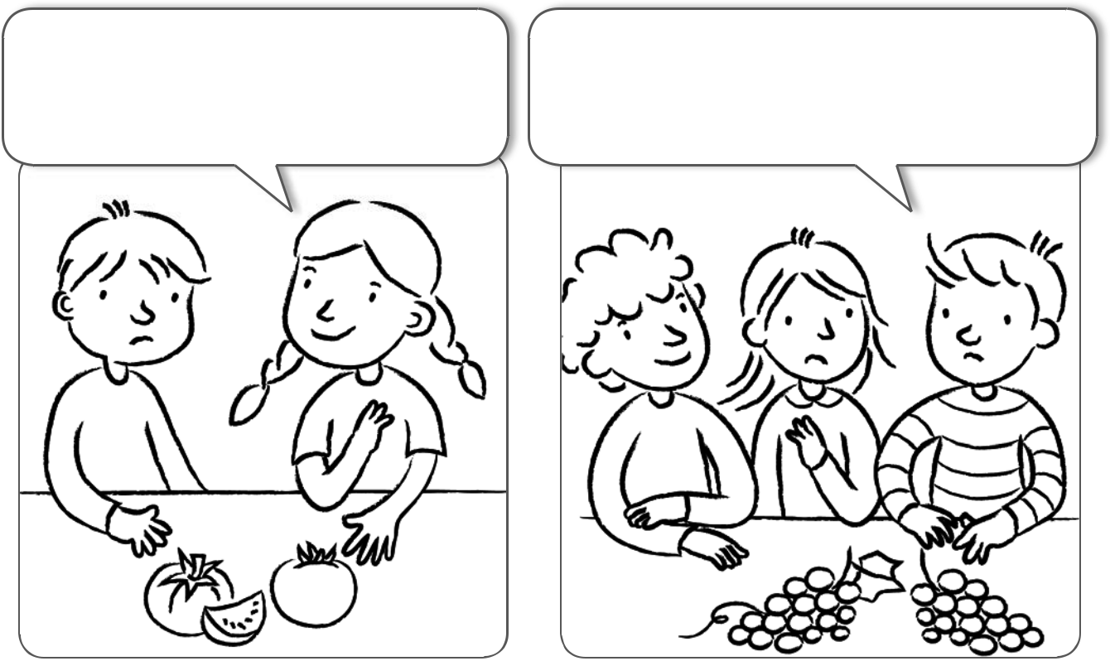

I 1 **like** / **don't like** tomatoes. I 3 **like** / **don't like** grapes.

My brother 2 **likes** / **doesn't like** My sister 4 **likes** / **doesn't like** grapes.

tomatoes. My brother 5 **likes** / **doesn't like** grapes.



|  |  |
| --- | --- |
| **4 Colour and write.** | ............ **/ 2** |
| Pokoloruj i napisz. |  |

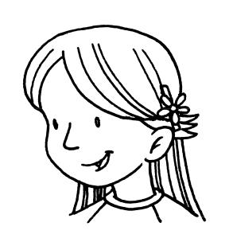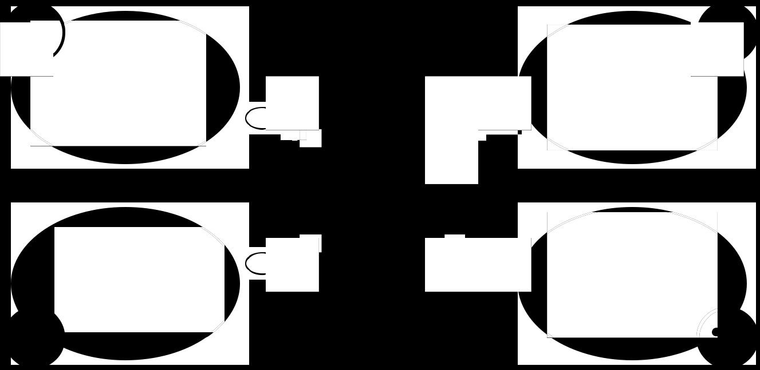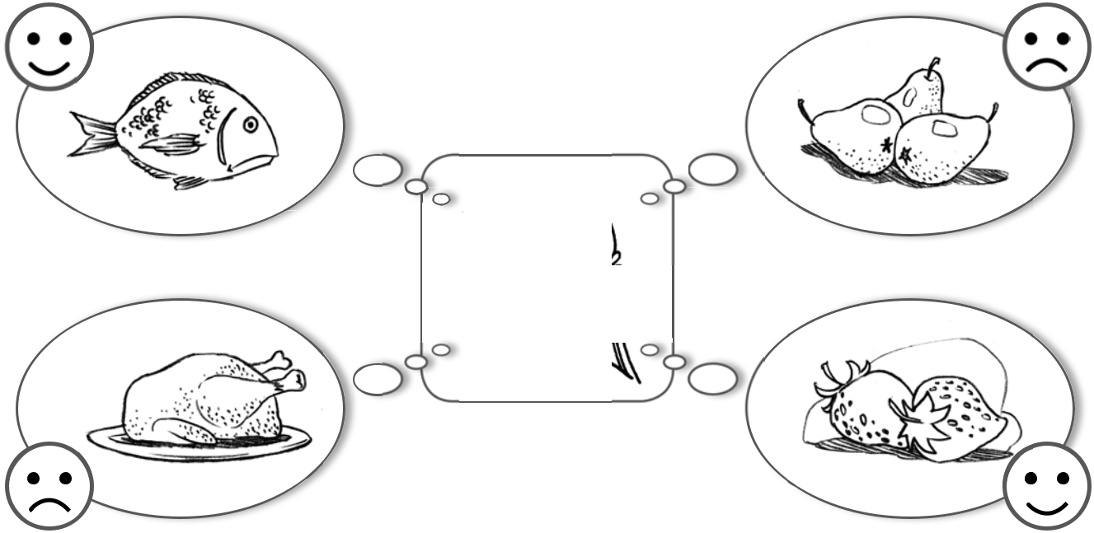

This is Jessica. She likes fish. She doesn't like pears.

She . She .



**22** PHOTOCOPIABLE © Pearson Education Ltd. 2016 *New English Adventure 2*