|  |  |  |
| --- | --- | --- |
| **My day** | **Test** | |
| Imię i nazwisko ......................................................................... | Klasa | .................. |
| **RAZEM:** ............ **/ 20**0 – 10 | 11–1516 | – 20 |

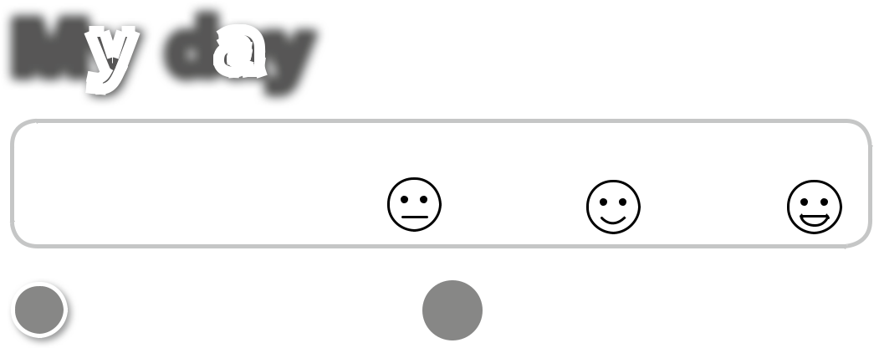

**1** **AUDIO**

**Listen and number.** **10**

Posłuchaj i ponumeruj.

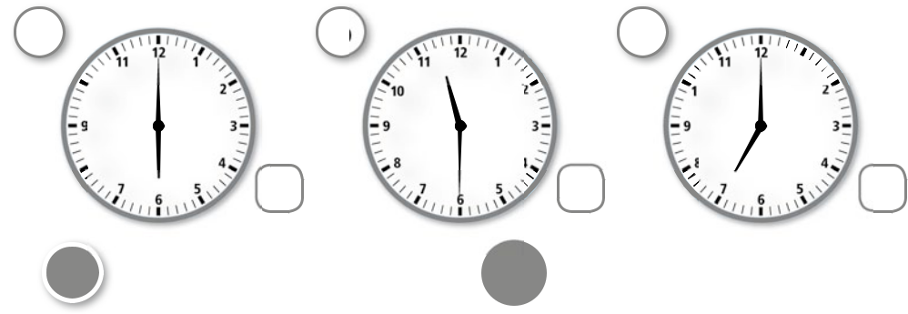

|  |  |
| --- | --- |
| **UNIT** | **ADVENTURE** |
|  |
| **5** |  |
| **EXTRA** |  |
| ............ **/ 4** |  |

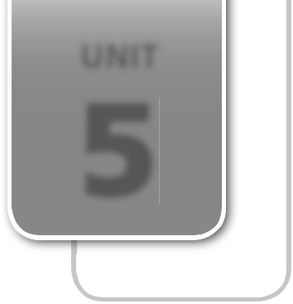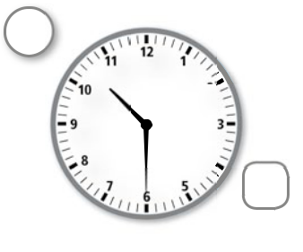

**a** **b** **c** **d**

|  |  |  |
| --- | --- | --- |
| **11** | **1** | **11** |
| **10** |  | **10** |

|  |  |  |  |  |
| --- | --- | --- | --- | --- |
| **1** | **11** | **1** | **11** | **1** |
| **2** | **10** | **2** | **10** | **2** |

**9**

**8** **4  8** **4  8** **4  8** **4**

|  |  |  |  |  |  |  |  |
| --- | --- | --- | --- | --- | --- | --- | --- |
| **7** | **5** | **7** | **5** | **7** | **5** | **7** | **5** |

1. **Listen and tick (**✔**).**

Posłuchaj i zaznacz ✔ (tak).

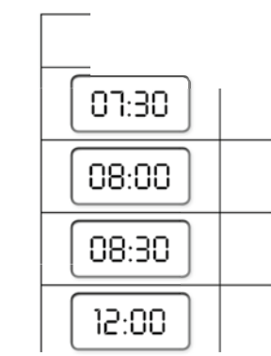

|  |  |
| --- | --- |
| **AUDIO** | **/ 4** |
| **11**............ |

|  |  |  |  |  |
| --- | --- | --- | --- | --- |
|  | have a shower | have breakfast | play | go to school |
|  |  |  |  |  |
|  |  |  |  |  |
|  |  |  |  |  |
|  |  |  |  |  |
|  |  |  |  |  |



1. **Look, read and match.**

Popatrz, przeczytaj i połącz.

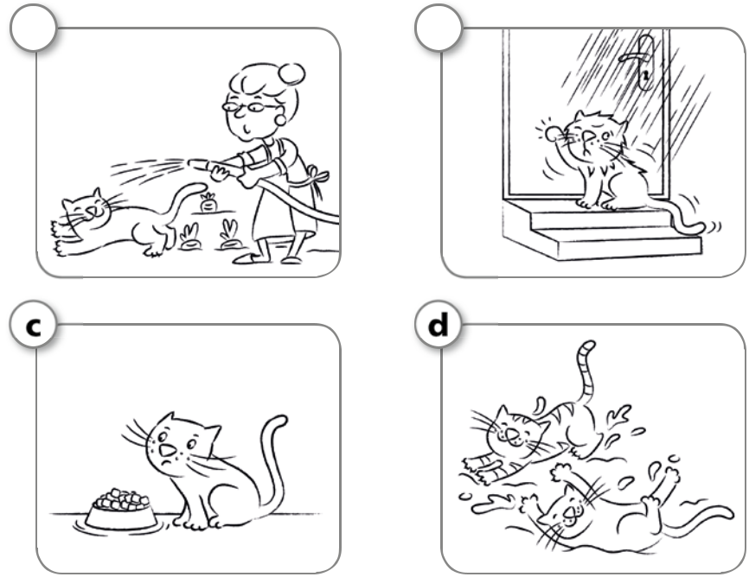

**a** **b**



**c** **d**



............ **/ 4**

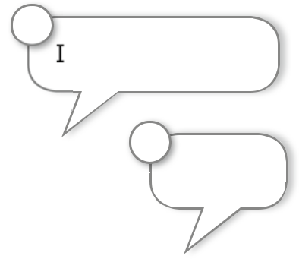

**1**

I have breakfast.

**2**

I play.

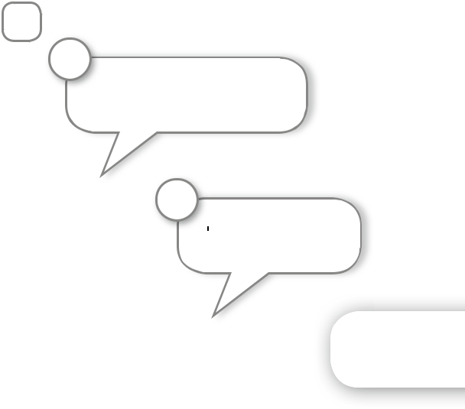

**3**

I have a shower.

**4**

I go home.



PHOTOCOPIABLE © Pearson Education Ltd. 2016 *New English Adventure 3* **37**

|  |  |  |  |  |  |  |  |
| --- | --- | --- | --- | --- | --- | --- | --- |
| **4** | **Read and write.** |  |  |  |  |  | ............ **/ 4** |
|  | Przeczytaj i napisz. |  |  |  |  |  |  |
|  | go | have | get play | | |  |  |
|  | SUNNY CAMP | | DAY PLAN | ~~up.~~ | |  |  |
|  | 07.00 – I | 1 |  |  |  |
|  | _______________ | |  |  |  |  |
|  |  |  | . |  |  |  |  |
|  | 08.00 – I have breakfast | | |  | . |  |  |
|  | 09.00 – I | 2 |  |  |  |  |
|  | _______________ | |  | lunch | . |  |
|  | 12.00 – I | 3 |  |  |  |
|  | _______________ | |  |  |  |  |
|  |  |  | . |  |  |  |  |
|  | 06.00 – I have supper | | |  |  | . |  |
|  |  | 4 |  |  |  |  |
|  | 10.00 – I |  |  | to bed | |  |
|  | _______________ | | |  |  |  |
| **5** | **Look and write. Then write about yourself.** | | | | |  | ............ **/ 4** |

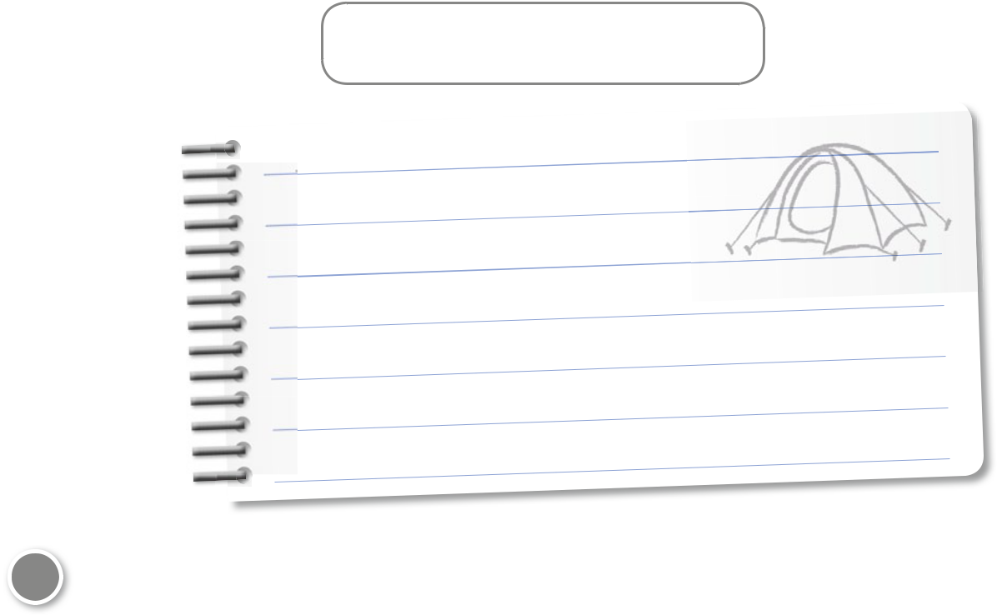

Popatrz i napisz. Następnie napisz o sobie.

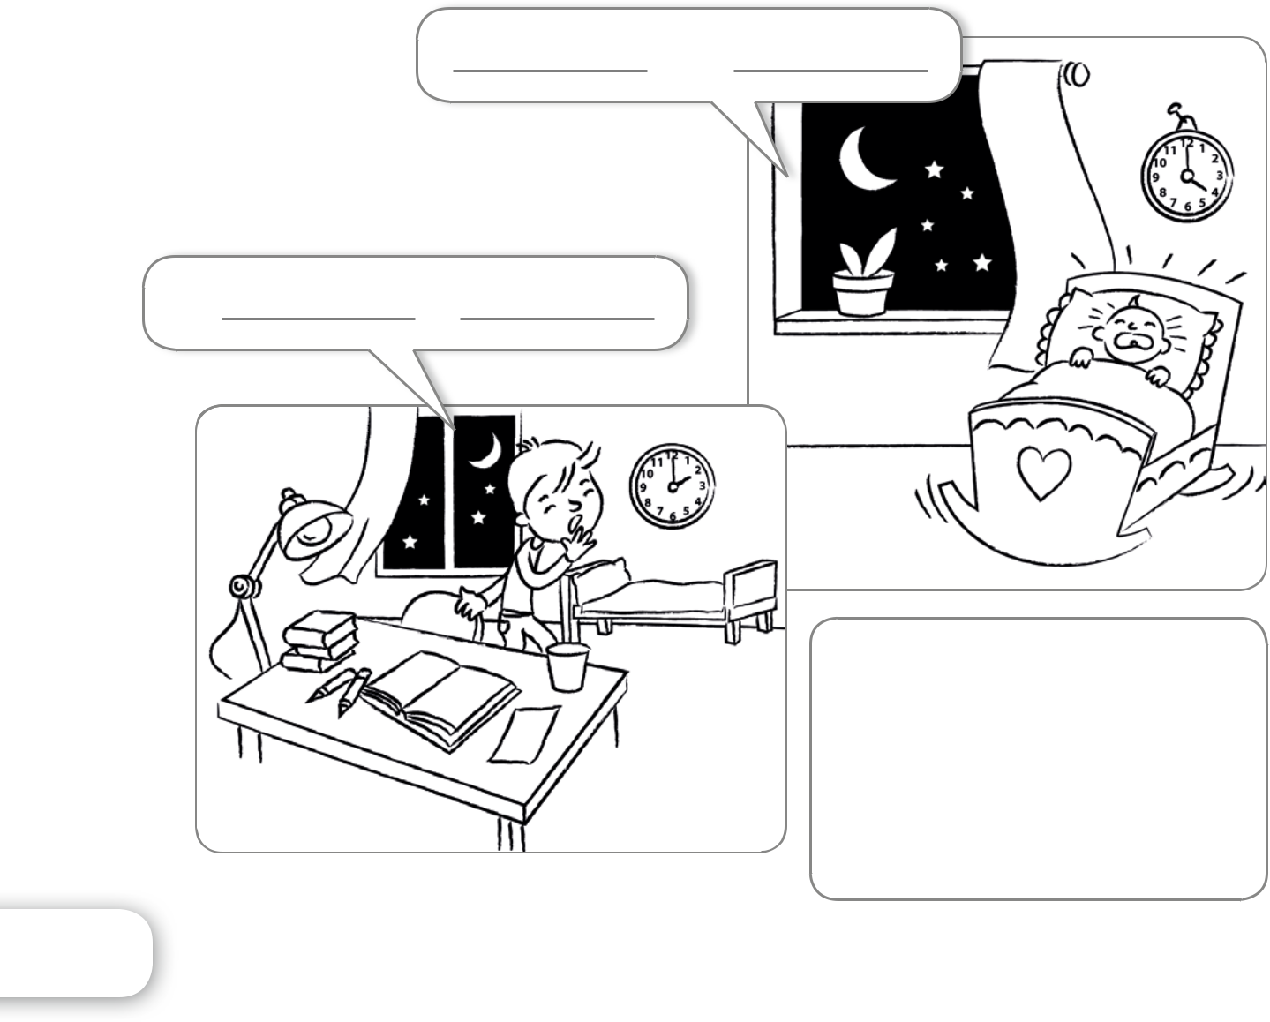

I up at .

I go at .

|  |  |  |
| --- | --- | --- |
|  | What about you? | |
| I |  | . |
| I |  | . |