|  |  |  |  |  |  |  |  |  |  |  |
| --- | --- | --- | --- | --- | --- | --- | --- | --- | --- | --- |
| **My house** | |  |  | **Test** | | | | | |  |
| Imię i nazwisko ......................................................................... | |  | Klasa .................. | | | | | | | |
| **RAZEM:** ............ **/ 15**0 – 5 |  | 6–10 |  | 11–15 | | | | | |  |
| **1 Listen and circle.** | **AUDIO** | |  |  |  |  |  |  |  |  |
|  | **20** |  |  |  |  |  |  |  |  |
| Posłuchaj i zakreśl. |  |  |  |  |  |  |  |  |  |  |
| **1** |  |  | **2** |  |  |  |  |  |  |  |
|  |  |  |  |  |  |  |  |  |  |  |
|  |  |  |  |  |  |  |  |  |  |  |
|  |  |  |  |  |  |  |  |  |  |  |
|  |  |  |  |  |  |  |  |  |  |  |
|  |  |  |  |  |  |  |  |  |  |  |
|  |  |  |  |  |  |  |  |  |  |  |
|  |  |  |  |  |  |  |  |  |  |  |

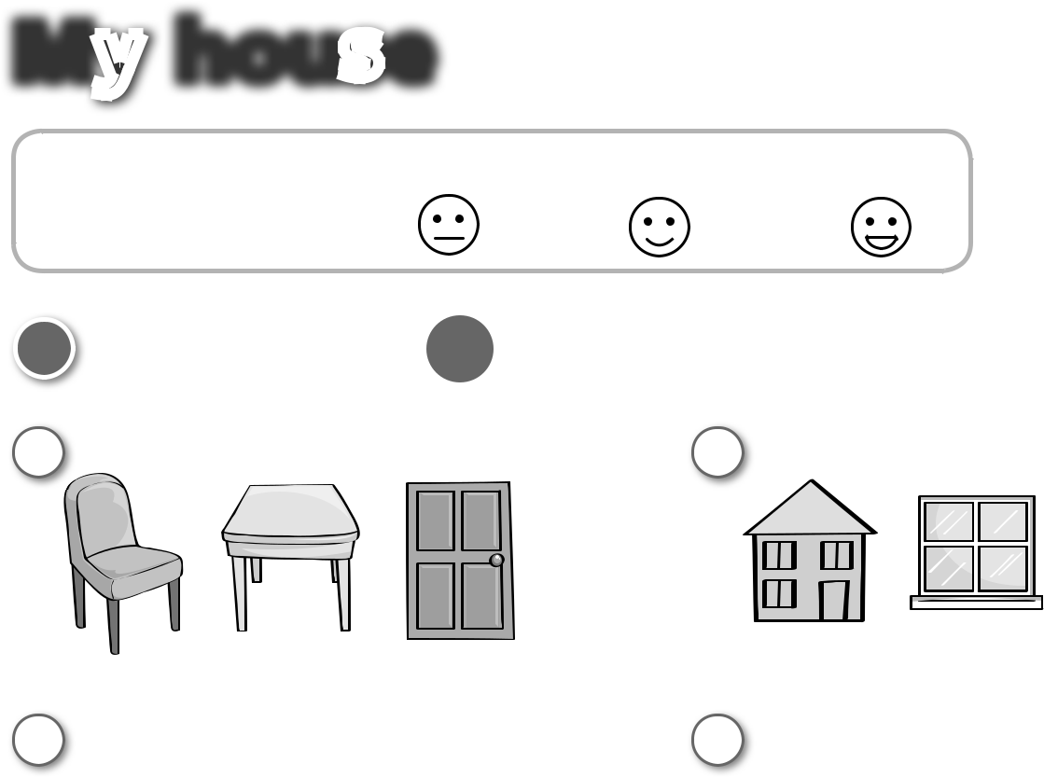

**3** **4**

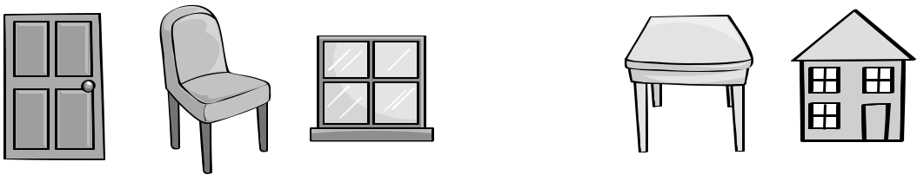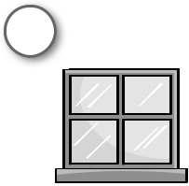

**5**

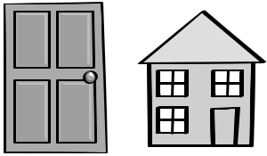

**UNIT**

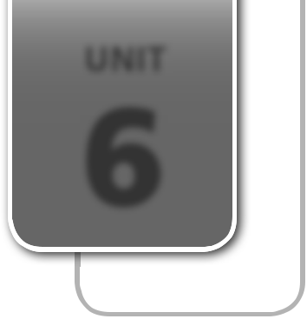

**6**

............ **/ 5**

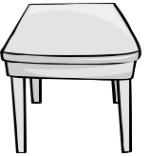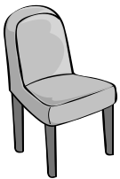

1. **Listen and tick (**✔**) or cross (**✘**).**

Posłuchaj i zaznacz ✔ (tak) lub ✘ (nie).

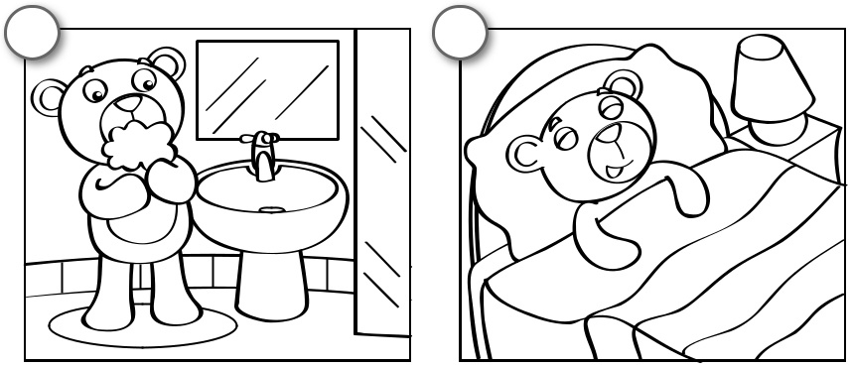

**1** **2**



|  |  |
| --- | --- |
| **AUDIO** | **/ 3** |
| **21**............ |

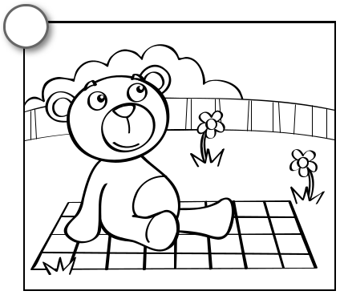

**3**



PHOTOCOPIABLE © Pearson Education Ltd. 2014 *New English Adventure 1* **17**

|  |  |
| --- | --- |
| **3 Trace, read and match.** | ............ **/ 5** |

Napisz po śladzie, przeczytaj i połącz z częściami domu.

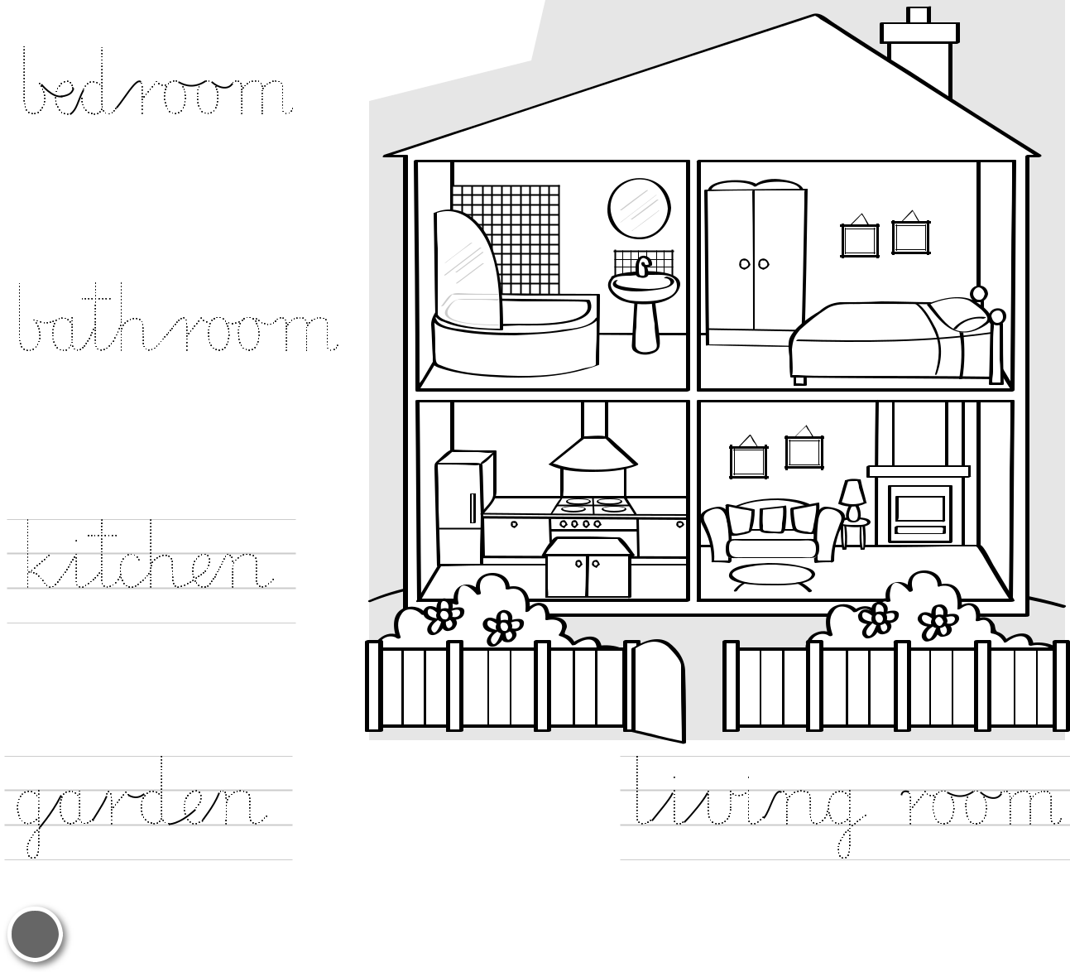

|  |  |
| --- | --- |
| **4 Read and draw.** | ............ **/ 2** |
| Przeczytaj i narysuj. |  |
| **1** | **2** |



a small chair a big house



**18** PHOTOCOPIABLE © Pearson Education Ltd. 2014 *New English Adventure 1*