**Food** **Test**

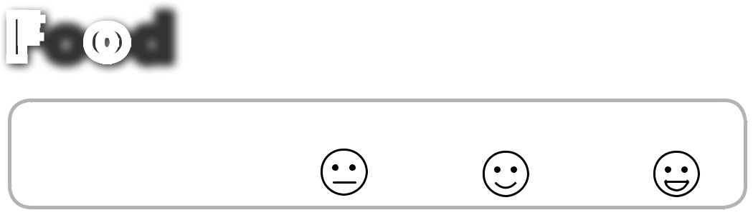

|  |  |  |  |  |
| --- | --- | --- | --- | --- |
| Imię i nazwisko | ......................................................................... | |  | Klasa .................. |
| **RAZEM:** ............ | **/ 15** | 0 – 5 | 6–10 | 11–15 |
| **1 Listen and circle.** | | | **AUDIO** |  |
| **14** |  |
| Posłuchaj i zakreśl. | |  |  |  |
| **1** |  |  |  | **2** |

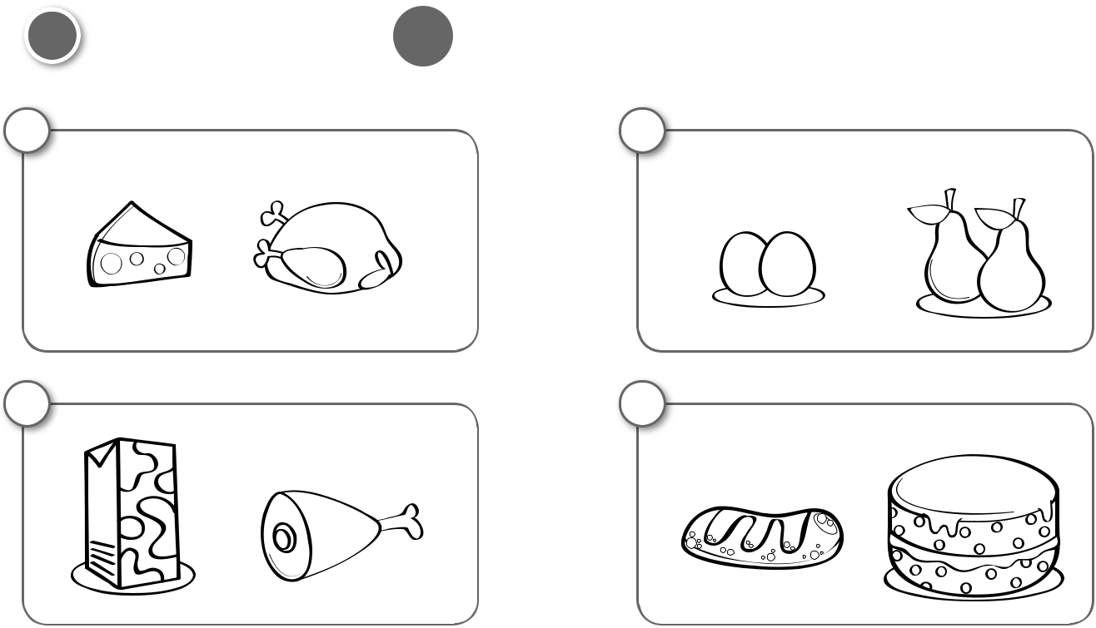

|  |  |  |
| --- | --- | --- |
| **UNIT** | | **ADVENTURE** |
|  |
| **4** |  |  |
| **EXTRA** | |  |
| ............ **/ 6** | |  |
|  |  |  |
|  |  |  |

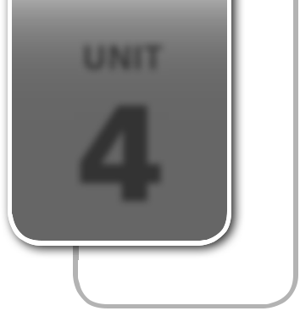

**3**

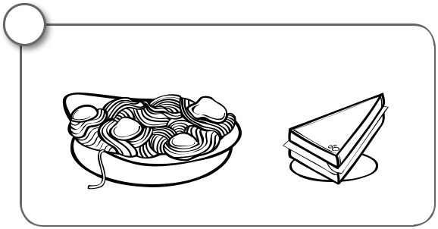

**5**



1. **Listen, read and draw.**

Posłuchaj, przeczytaj i narysuj.

**4**

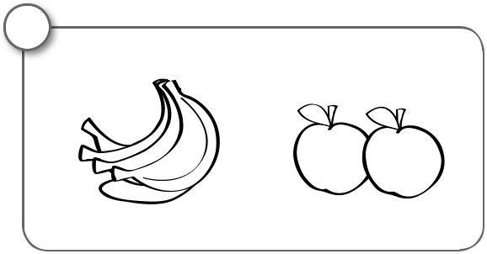

**6**



|  |  |
| --- | --- |
| **AUDIO** | **/ 3** |
| **15**............ |

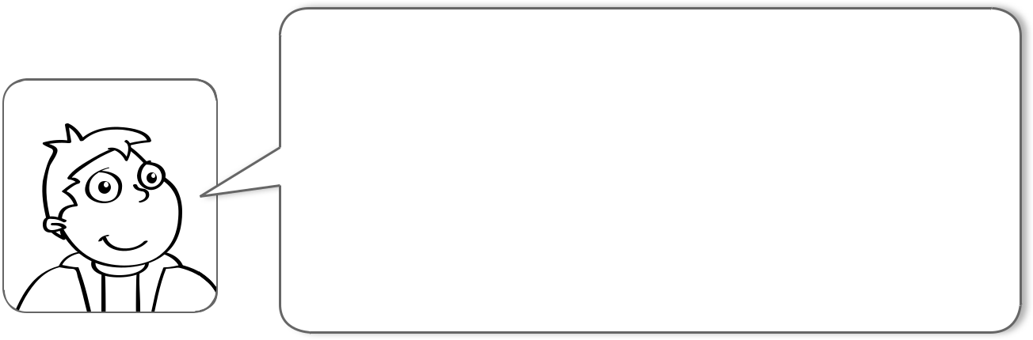

1. I like bread.
2. I like cheese.
3. I like milk.



PHOTOCOPIABLE © Pearson Education Ltd. 2014 *New English Adventure 1* **31**



1. **Listen and circle 4 things Martha likes.**

Posłuchaj i zakreśl 4 potrawy, które lubi Marta.

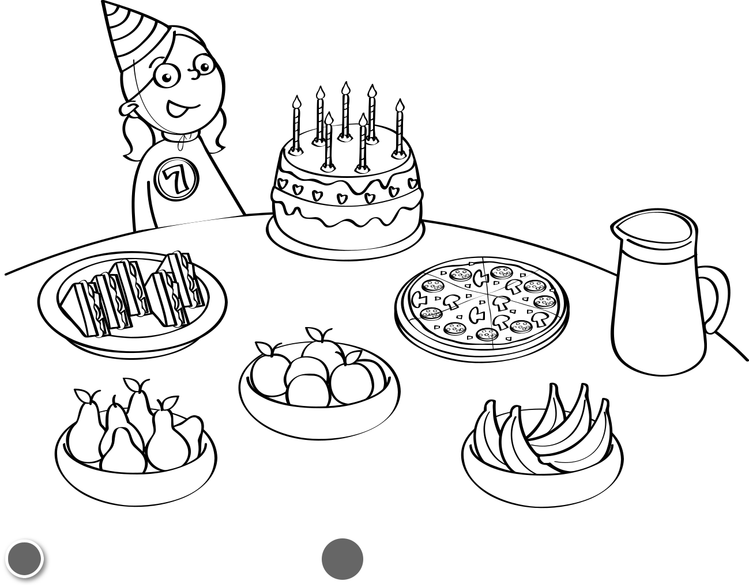

|  |  |
| --- | --- |
| **AUDIO** | **/ 4** |
| **16**............ |



1. **Listen, read and draw.**

Posłuchaj, przeczytaj i narysuj.

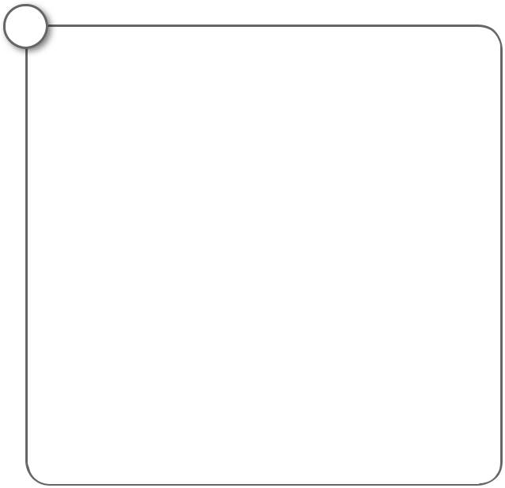

**1**

**AUDIO**

**17**

............ **/ 2**

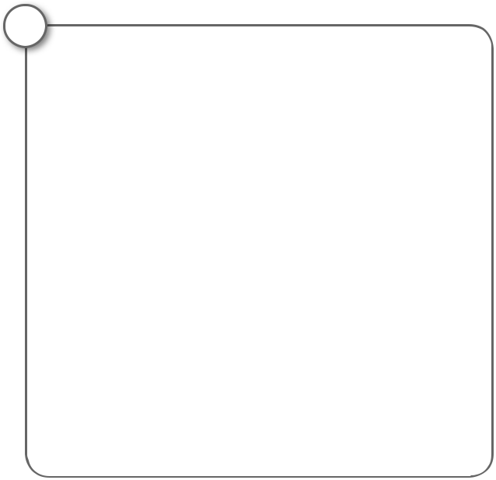

**2**

three yellow pears six red apples

