|  |  |  |  |  |  |  |  |  |  |  |  |  |
| --- | --- | --- | --- | --- | --- | --- | --- | --- | --- | --- | --- | --- |
| **I can jump** | | | | | | |  |  | **Test** | | **UNIT** | |
|  |  | **5** | |
|  | Imię i nazwisko ......................................................................... | | | | |  |  |  | Klasa .................. | | | |
|  | **RAZEM:/ 15**0 – 7............ | | | | |  | 8–11 |  | 12–15 | |  |  |
| **1 Listen and circle.** | | | | | **AUDIO** | |  |  |  |  | ............ **/ 4** | |
| **10** | |  |  |  |  |
|  | Posłuchaj i zakreśl. | | | |  |  |  |  |  |  |  |  |
| **1** |  |  |  |  |  |  |  | **2** |  |  |  |  |
|  |  |  |  |  |  |  |  |  |  |  |  |  |
|  |  |  |  |  |  |  |  |  |  |  |  |  |
|  |  |  |  |  |  |  |  |  |  |  |  |  |
|  |  |  |  |  |  |  |  |  |  |  |  |  |
|  |  |  |  |  |  |  |  |  |  |  |  |  |
|  |  |  |  |  |  |  |  |  |  |  |  |  |
|  |  |  |  |  |  |  |  |  |  |  |  |  |
|  |  |  |  |  |  |  |  |  |  |  |  |  |
|  |  |  |  |  |  |  |  |  |  |  |  |  |
|  |  |  |  |  |  |  |  |  |  |  |  |  |

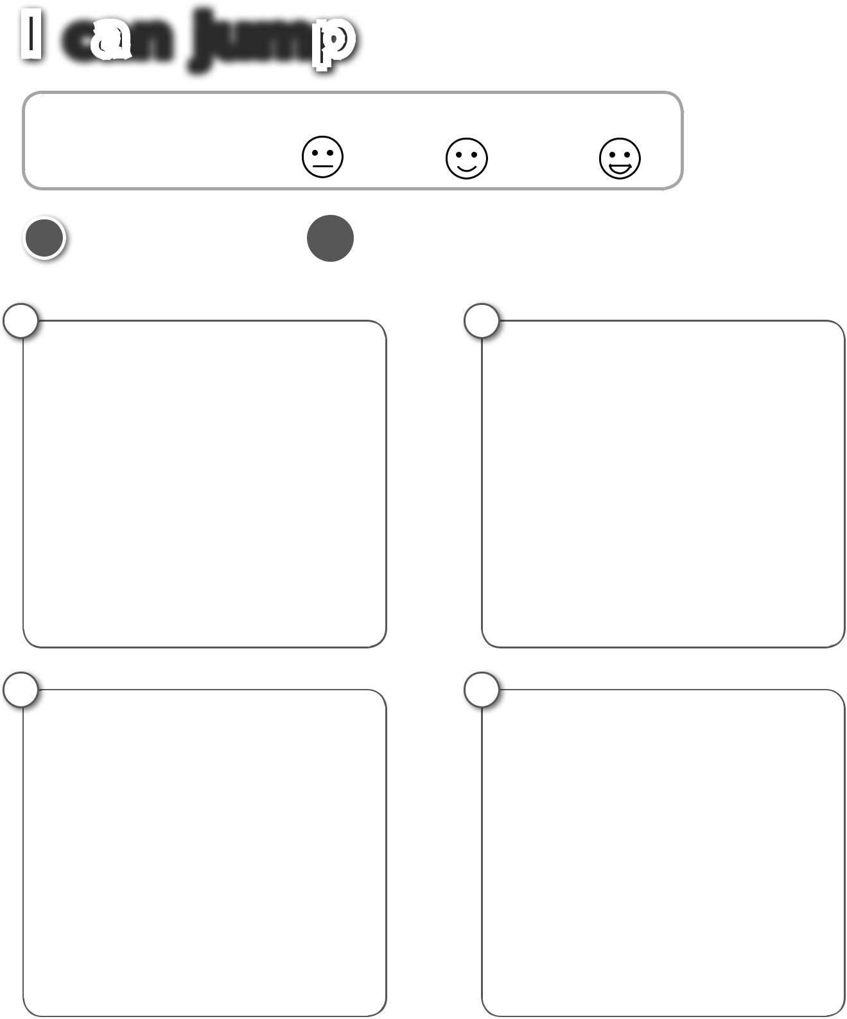

**3**

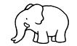

1. **Listen and circle.**

Posłuchaj i zakreśl.

**4**



|  |  |
| --- | --- |
| **AUDIO** | **/ 4** |
| **11**............ |

1. Jenny **can** / **can’t** swim.
2. Jenny **can** / **can’t** ride a bike.
3. David **can** / **can’t** climb.
4. David **can** / **can’t** run.



PHOTOCOPIABLE © Pearson Education Ltd. 2016 *New English Adventure 2* **19**

|  |  |
| --- | --- |
| **3 Look, read and match.** | ............ **/ 5** |
| Popatrz, przeczytaj i połącz. |  |

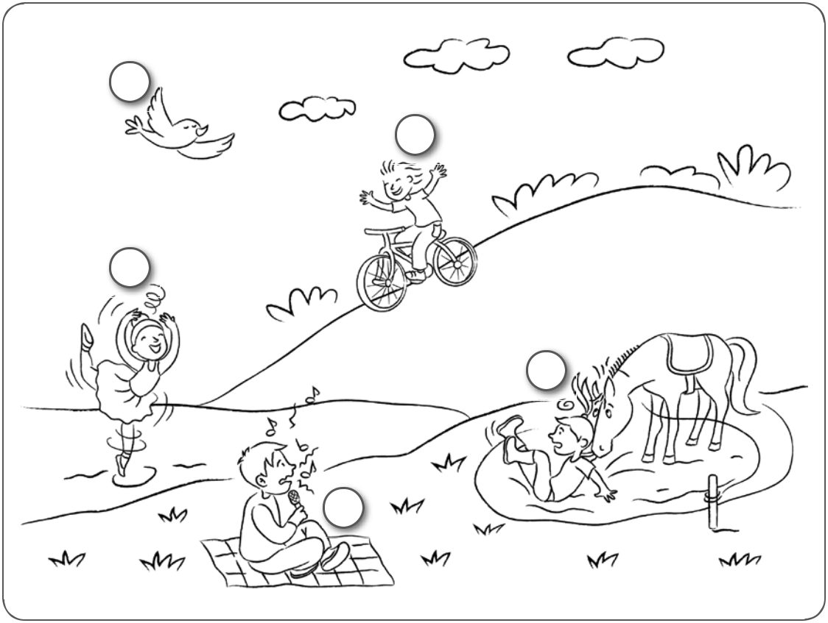

**1**

**2**

**3**

**4**

**5**

|  |  |  |
| --- | --- | --- |
| **1** | I can | dance. |
| **2** | I can | ride a horse. |
| **3** | I can | sing. |
| **4** | I can’t | fly. |
| **5** | I can’t | ride a bike. |



|  |  |  |  |  |  |  |
| --- | --- | --- | --- | --- | --- | --- |
| **4 Colour and write.** | | | | | ............ **/ 2** | |
| Pokoloruj i napisz. | | | | |  |  |
|  |  | I’m a monkey. | | |  | . |
|  |  |
|  |  | I can |  | |
|  |  | I can’t | |  |  | . |

